**IoT Based Water Quality Testing System**

**Dr. Siddhartha Arjaria, Priya Sharma,**

**Shubham Kumar, Lalit Katheria, Suraj Kumar**

Department of Information Technology

Rajkiya Engineering College, Banda

**ABSTRACT**

Currently, the ranking of India is 120 among 122 countries in the water quality index. If we observe globally, around four billion people live in those areas where water scarcity is at a high level. Nowadays the problem of water pollution is widespread and harmful to our health. So, it is important to determine the properties of water quality and detects all the parameters. The standard method of water testing is to collect samples of water manually and send them to the laboratory to test and analyze. This process takes a large amount of time in water testing. The implementation of a water quality monitoring system is accomplished with the emerging technology (Internet of Things) for water quality in real-time through various sensors and ESP8266 Wi-Fi module. This paper also explored the physical and chemical parameters of water as conductivity, pH, temperature, turbidity, and dissolve oxygen solids to estimate the quality of water.

The primary purpose of making this portable device is to awareness in rural areas about the impurities of water and heavy metal pollutants like arsenic, chromium, lead, etc. It will also detect the number of impurities present in water and it is safe for drinking or not. It is necessary to developing and evaluating the water quality. This paper described all the parameters using Arduino UNO, sensors, and representation with the cloud web portal.

**Keywords**: ESP8266 (Wi-Fi), PH, conductivity, Turbidity, TDS (Total Dissolved Solids), Temperature, Water Quality Monitoring, Water Testing, Arduino Uno.

**Objective:** The objective of this paper is summarized as below:

* The main objective of this paper is to prelude the testing of water quality and making it more innovative using software, embedded system, and IoT (Internet of things). It will detect all the water parameters at once and help to make it more preferable drinking water.
* The purpose of making this portable device is to aware people of the impurities of water and heavy metal pollutants like arsenic, chromium, lead, copper, zinc and mercury, etc.
* It will also detect the number of impurities present in water and in this paper, it will also be known whether this water is safe to drink or not.

1. **INTRODUCTION**

Water is a priceless resource on our planet and also necessary for all human beings. It is essential to protect water resources from industrial wastages and disposal etc. Major polluted urban areas had polluted rivers and other sources of natural water due to industrialization and also affected other small domestic areas. Switzerland is recognized as the country with the best quality of tap water in the world. In this paper, the removal of water quality status of some areas of Uttar Pradesh is also mentioned. Potable water is most important and necessary for all human beings and it should be clean and safe. It is necessary to identify any existing problems and issues in water quality. Every day around two million tons of human waste is deposited into resources of water, so maintaining water quality is critical. Water quality monitoring is beneficial for rural areas as well as urban areas and alerts them of currently ongoing and emerging problems of potable water. This paper will look into the methodology of the water quality index for monitoring, testing, and purification of water.

In addition to monitoring the water quality using technology, there has also been some research carried out in Internet of Things (IoT) technology and water quality sensors to measure and monitor factors, like pH, temperature, conductivity, turbidity, and dissolved oxygen. For measuring the water quality in different areas, there will be one portable device using sensors and probes, which will detect several parameters of water and it will also measure in real-time from remote locations. To protect and make a sustainable nature, we should maintain a proper balance in natural resources. Water quality monitoring is an essential part of human beings and animals as well as water bodies.

## WHO’s (World Health Organization) Water-related report?

1. According to several surveys 3.4 million people, mostly children die annually from water- related diseases.

2. Every year, about 2.2 million people die of diarrhea, of which about 90% of deaths occur in children.

3. In countries that are not highly developed, 22% of health care facilities have no water service, 21% have no sanitation service, and 22% have no waste management services.

4. Around 435 million people worldwide are taking water from unsafe wells and springs.

5. About 144 million people store untreated surface water from lakes, ponds, rivers, and streams.

* The water quality monitoring program is an important tool to help improve the quality of water in India.
* There are 7 states affected by arsenic in water in India. Near about 40 districts are suffering from the arsenic present in water in Uttar Pradesh.
* Mostly in Kanpur, Ajodhya, Sitapur is highly affected areas by arsenic which causes cancer in the human body.
* There are 17 states in India where Fluoride is found in water. 18 districts of Uttar Pradesh are suffering from fluoridated water.

**Table: Ideal water ranges in accordance with WHO standards**.

|  |  |  |
| --- | --- | --- |
| **Parameter Monitored** | **Quality**  Range | Units |
| Turbidity | 5-10 | NTU |
| PH | 6.5-8.5 | PH |
| Conductivity | 300-800 | Micro S/cm |

Graphical Representation of water pollution level in Banda city is given by in the below chart:

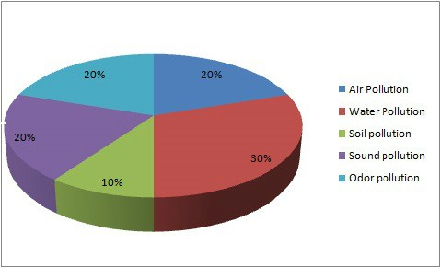

**Figure1**: Graphical Representation of various pollution levels (air, water, soil…etc)

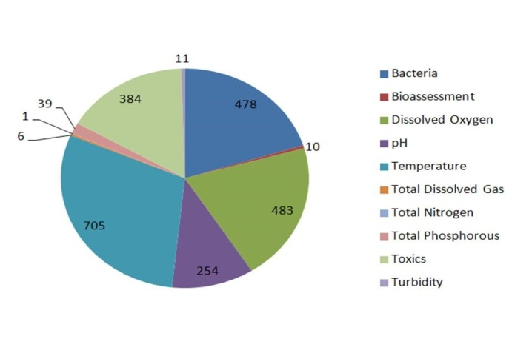

Figure 2 Pollution level various parameter of water

**1.2 Water-related problem and the solution**

There are many problems in drinking water in our country:

1. In India 50% of districts are suffering from nitrate in groundwater and nitrate in drinking water can cause methemoglobinemia or the decreased ability of blood to carry vital oxygen around the body.
2. In India, around 301 districts are suffering from contamination of iron in groundwater and excessive iron in water causes hemochromatosis in the human body.
3. In India, about 335 districts are suffering from contamination of fluorides in groundwater and excessive fluoride affects the teeth and bones.
4. In India, nearly 212 districts are suffering from salinity (salty Water) and it causes cardiovascular diseases, diarrhea, and abnormal pain.
5. In India, 153 districts are suffering from contamination of arsenic in groundwater and it causes cancer and skin lesions.
6. In India, 93 districts are suffering from lead, and excess of the lead causes high blood pressure and anemia.
7. In India, 30 districts are suffering from chromium and excessive lead causes lung cancer.

**Water- related main problems and their solutions through this paper**

1. **Problem:** Provision of potable water and sanitation in rural areas**.**
2. **Problem:** Rural sanitation.
3. **Problem:** Purification of impure water in rural India.
4. **LITERATURE REVIEW**

Water quality is a critical issue in India as well as in other countries. Several researchers have mentioned different methods and technologies in their papers. The main concept of our project is to develop an efficient, low cost and real-time water quality monitoring model. It will assimilate the wireless technology, sensors, and the Internet of Things. We are developing a unique portable device which will tell the quality of water either it is drinkable or not. The web application also shows all the parameters of water and insurance of safe drinking water. After study the research papers of authors who have completed previous works in this field. We observed that many of the researchers have mentioned the different technologies to solve the water problems that are given below:

Chaudhary_et.al (2019), the work in this paper is focusing on the Deep learning and Belief rule-based system. They proposed a wireless sensor network including microcontroller and the internet of things. The technologies in this paper included big data analytics system, neural network model, and sensors. They also mentioned the hardware and software design of the system [1].

Daigavane, V.V., and Gaikwad, M.A. (2017) proposed a water quality monitoring system based on IoT. In their paper, they explained pH sensor, temperature sensor, turbidity sensor, and flow sensor. The Arduino model and Wi-Fi module are included in their system. They presented the system design with minimum cost [2].

Ramesh_et.al (2017) the work in this paper is focusing on water pollution, soil and waste management. The authors have introduced about the sensors for the detection of pH, turbidity, and dissolved oxygen. In this paper, they also discussed the water resources and their management [3].

Sevda Mohammadi_et.al (2020), the system proposed integrates different technologies like 3D printing and double-ring resonator. The parameter involved in the water monitoring is chemical oxygen demand and measurement of glucose in DI-water. Moreover, this system presented as low cost and hazard free using a 3D printed micro fluidic channel [4].

Yiheng Chen and Dawei Han (2018), demonstrated the process of data collection, transmission, storage and, visualization. They proposed big data, the Internet of things and, smart city as an emerging technology for monitoring water quality. Wireless network and high-frequency water quality are displayed in their paper [5].

Nikhil Kumar Koditala and Purnendu Shekar Pandey (2018), focused on emerging technologies like Machine Learning, IoT and, Cloud Computing. It can be evaluated dataset of R-squared value for a better approach. Temperature sensors and measurement is also mentioned in the proposed model. Electronic mail is also received to the user [6].

Muhammad Niswar_et.al (2018), set-up a web-based monitoring application using a node-red dashboard for accessing water quality levels. The authors have addressed about the farming of soft shell crab in south-east Asian countries. Small embedded devices and Lora based wireless network interface is used in their system. They also proposed temperature sensors, salinity, and intelligent sensors for water quality monitoring [7].

Jiping Jiang_et.al (2020) designed the surface water quality monitoring networks with the implementation of Water Quality modeling and smart city. The methods in this paper included a novel design method and optimization method. Experiences on station location, sampling frequency, and water quality indicators are designed for water quality monitoring [8].

Kumar and Samalla (2019) addressed about Design and Development of Water Quality Monitoring System in IoT. In this paper, they presented their model using CO2 sensor, microcontrollers (RPI), Temperature sensor, and pH sensor. They proposed their model using sensors in the form of digital to analog. Some alarm intimation sound is also created. In their system, they explained the cloud system to send all the data.[9]

Kartakis_et.al entitled topic on analysis of the distributed network. An author has addressed technologies as adaptive edge analytics and localization scheme. They used it with the combination of lightweight compression and anomaly detection for distribution networks of water. Moreover, they had used effectively localize water burst events and detection of variations in vibration [10].

Madhavireddy and Koteswarrao (2018) proposed the system with new technology Internet of Things. They have introduced the wireless sensor network for water monitoring. It is explained by data acquisition and transmission system. They used a web server for showing the values of physical parameters in water. They also applied a buzzer system for the working of sensors. [11]

In This paper, work on developing a low-cost portable device for findings of water monitoring, testing and, purification of water samples based on the Internet of things (IoT), parameter-based sensors, and software application. It will also be applicable to rural areas for potable water.

1. **Working of Project:**
2. **Sensors and Hardware:** Hardware components and Sensors which are used in this paper listed below…..

* Arduino Uno
* Wi-Fi module for Arduino
* ESP8266
* OLED for Arduino
* Power bank for Arduino Power
* Breadboard
* Jumper wire set M to M, M to F, F to F
* Soldering iron, paste, and wire
* PH sensor with module for Arduino
* Turbidity sensor with module for Arduino
* Temperature sensor for Water
* Dissolve Oxygen sensor for Arduino
* Conductivity sensor for Water
* TDS sensor for Water
* Electrochemical, Biochemical sensor for detection of toxic metals in Water
* A buzzer
* LED multi color and red, green, blue individual
* Module for dissolved oxygen sensor
* Male Power port for Arduino

1. **Proposed Model:**

1. In this paper, the team proposed a water quality monitoring system based on the Internet of Things.

2. Water properties can be physical (temperature, TDS, Conductivity, turbidity, etc.), chemical (pH and dissolved oxygen), and organic (algae and phytoplankton).

3. In the proposed system, the physical and chemical properties of water are investigated in various water sources such as drinking water, swimming pools, rivers, ponds, canals, etc, and industrial wastewater.

4. This section is made up of two distinct parts.

* In the first part, a brief overview of the entire system is presented.
* In the second part, the system design will be discussed in detail. The second part includes both hardware implementation and software.

1. **Proposed Work:** Proposed Work of this Paper in given below:
2. First, collect the sample of water from different places then perform different types of testing on the collecting samples, physical and chemicals, Toxic metal, microbiological characteristics of various water resources such as domestic drinkable water, river, ponds, canals, etc, and industrial wastewater is investigated (pH, TDS, Turbidity, conductivity, temperature) with sensors.
3. In this paper, want to detect various toxic elements in collecting Water samples like (As, F, Na, Mg, etc...).
4. **.** If any impurities, toxins are found in collecting water samples, then in this paper it is explained how those impurities can be eliminated?

|  |
| --- |
| **Show output in Webpage**  **Process Data in Cloud**  **Arduino**  **Uno**  **Temperature sensor**  **Chemical Parameters Testing**  **Power bank**  **Conductivity Sensor**  **Buzzer**  **OLED for Output**  **Wi-Fi module nodemcu for Arduino**  **Dissolve Oxygen Sensor**  **Turbidity Sensor**  **TDS Sensor**  **PH Sensor** |

**Figure 3**: Overview of the system architecture

1. **Sensors Description**:

* **pH Sensor:** pH sensor is basically used to define the acidity or basicity of liquids. This sensor uses a ph scale to test the liquids, in the pH scale if any liquid having a pH value below 7 then it’s a more acidic solution and if the solution having greater than 7 then it’s a more basic solution. pH value varies between 0-14. Any solution having a pH value of 7 and its neutral solution.

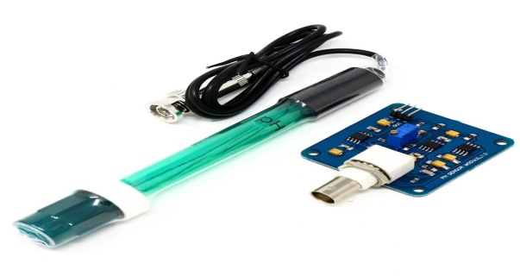

**Figure3.1**: PH sensor with module for Arduino

* **Temperature Sensor:** Temperature sensor is basically used to identify engine overheating or an unusual temperature rise. To measure temperature readings of different types of water, use a temperature sensor which is made up of two metals. It generates the electrical voltage or resistance change in temperature.

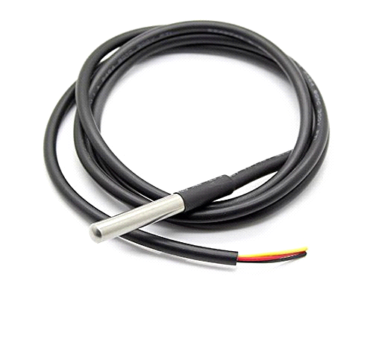

**Figure3.2:** Temperature sensor

* **TDS Sensor:** Total dissolved solids are a measure of a combination of organic and inorganic substances present in water. TDS concentration can be determined by the TDS meter. It is used to indicate the water quality level.

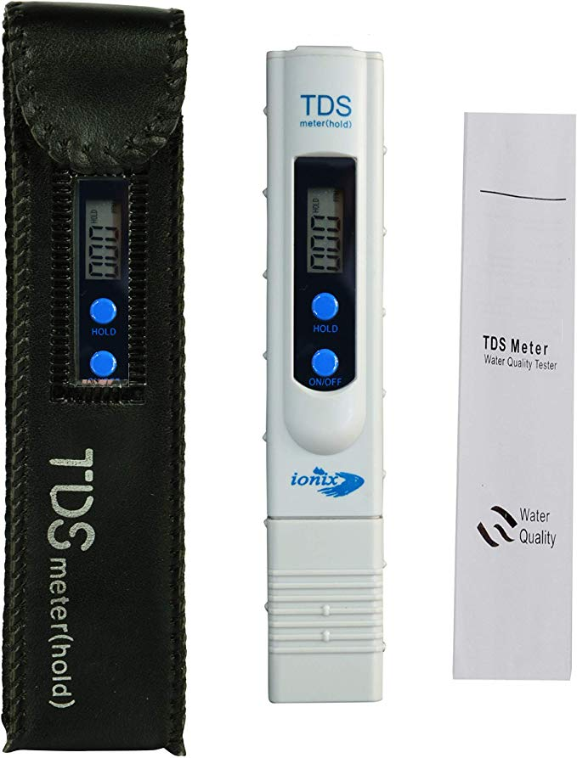

**Figure3.3**: TDS sensor for Water

* **Turbidity Sensor**: The Turbidity sensor monitors the transmitted light to determine the turbidity of water due to suspended sediment.

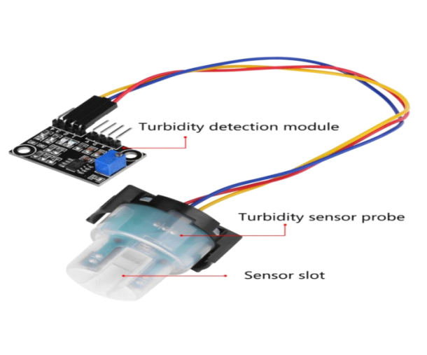**Figure3.4:** Turbidity sensor with module for Arduino

* **Conductivity Sensor:** A conductivity sensor measures the conductivity of the solution and presented ions in it. Water conductivity sensors are used in water-quality applications. If more ions are present in the solution, shows the more conductive the solution.

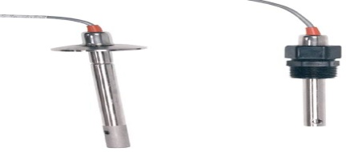

**Figure3.5**: Conductivity sensor for Water

* **Dissolved Oxygen Sensor: A** Dissolved oxygen sensor is designed for use in the water treatment plant, river monitoring, and check the water quality. This sensor is basically used for the value of dissolved oxygen in the given water sample with the use of the oxidation-reduction process.

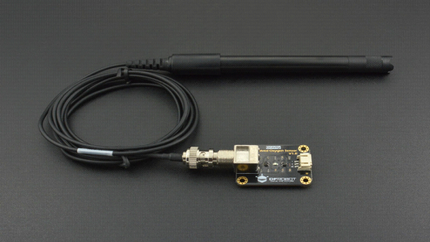

**Figure3.6**: Dissolve Oxygen sensor for Arduino

* **Arduino Uno:** The Arduino UNO is a microcontroller board having an ATmega16 microchip to use the programming and work with the sensors.

Arduino reads the analog pins and digital pins to take the data from sensors and pins are also work as output pins to give the output from the arduino on a serial monitor or LCD screen.

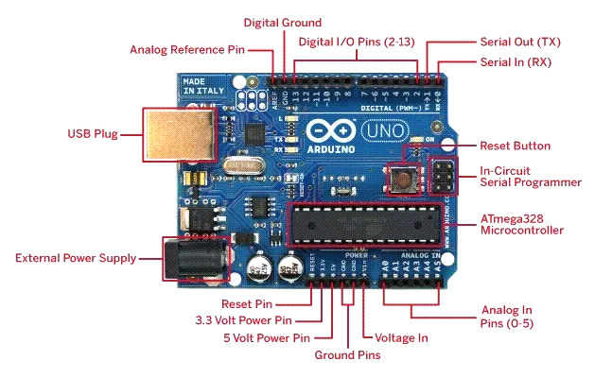

**Figure3.7**: Arduino Uno

* **Power bank:** The Power bank contains a 3.6V lithium battery, so to put out regulated 5V; it contains a power up-converter. Arduino can be powered with the USB connection of the power bank as an external the power supply.

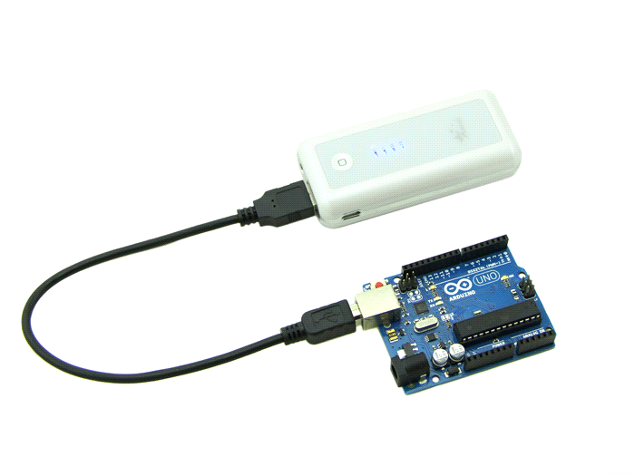

**Figure3.8**: Power bank for Arduino Power

* **OLED for Output:** OLED stands for Organic Light Emitting Diode. It is used to initialize the display and provide a low-level display function after installing Arduino libraries.

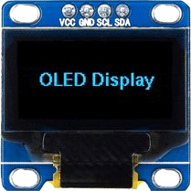

**Figure3.9**: OLED for Arduino

* **Wi-Fi Module nodemcu for Arduino:**

The ESP8266 is an integrated Wi-Fi circuit to provide wireless fidelity’ to the Arduino board. It is used for connectivity to the internet and provides more functionality to this paper.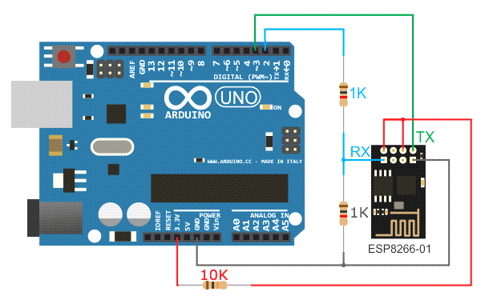

**Figure3.10**: Wi-Fi Module for Arduino Uno

* **Buzzer:** Buzzer is an audio signaling piezoelectric device. It is connected with Arduino and used as an alarm device and confirmation of user input.

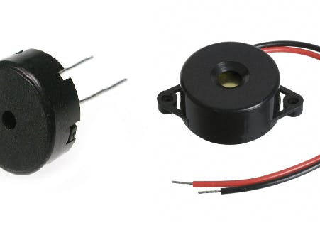

**Figure3.11**: Buzzer

1. **SYSTEM WORKING PROCESS:**

System working process is given below:

1. The main process of the system is done by Arduino where the Atmega16 microcontroller works according to the programming code written in the Arduino IDE, and which data is to be taken from which sensor and how to use it, by the microcontroller, When all the sensors are encoded in the Arduino's analog pins, the PIN number is defined in the code, after that the water sample is taken into the flask and all the sensors are drowned in it,

2. Then after that connect the Arduino to the computer or laptop via USB, select the port number from the USB to which the Arduino is connected, like COM3 and click on compile and upload the code, as soon as the code upload Let's say, Arduino works according to the code written in the IDE, such as connecting to Wi-Fi, and collecting data from the sensor and showing that data on the screen.

3. Once connected to the Internet, Arduino connects to the Internet with the help of the ESP8266 module, and writes the code in the code to write the data in the website where we can see the graph of the parameter according to the data, According to the code given in the code, after a few seconds the new website is written on the right, a graph is formed from the S type, after testing different waters different values ​​come out, which we use on the screen (LCD) of the Internet. With the help of any website or webpage, you can see it from any mobile or laptop.

4. In this way we can use this device both offline and online, and save the data of the water sample to us according to the date, time and, location, and can also send it to anyone with the help of the internet. This is how our entire system works.

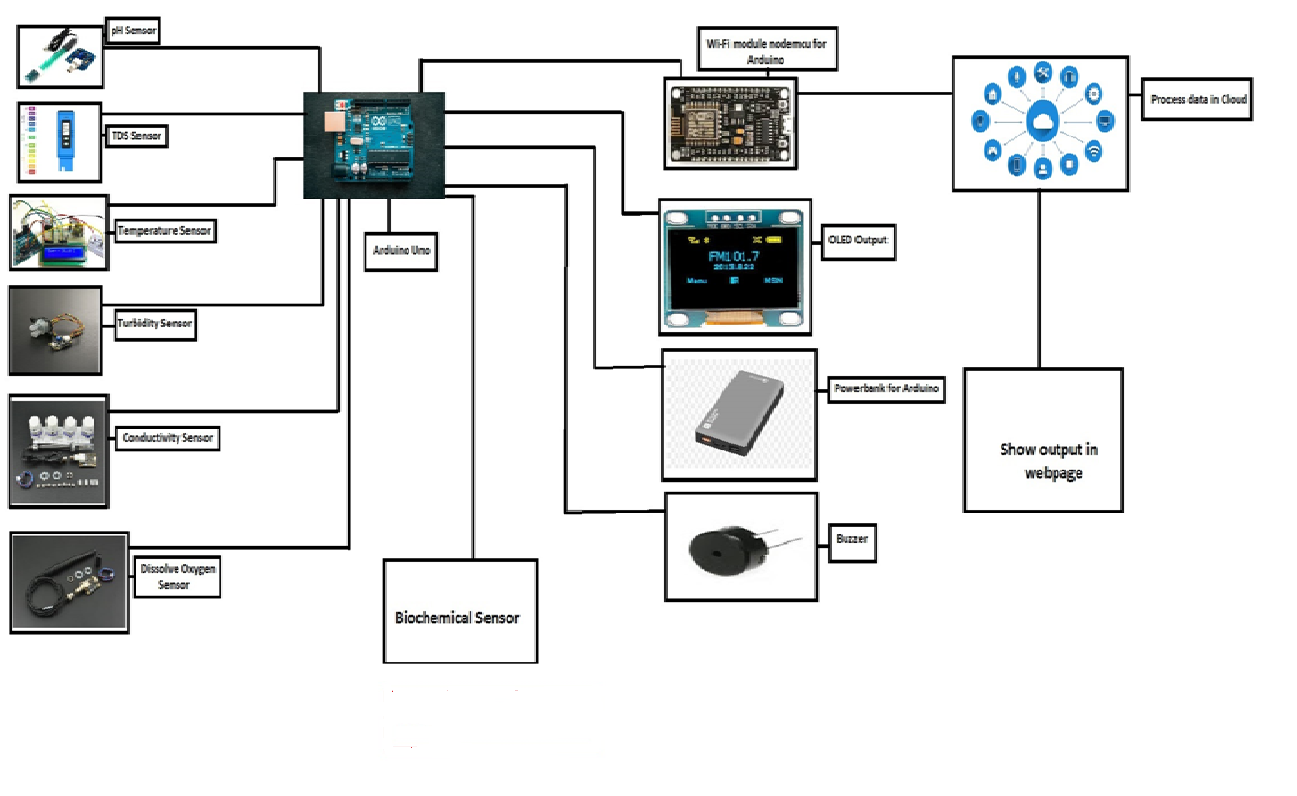

**Figure 4**: System working process diagram

**4.1 Block Diagram:** Block diagram of this paper is summarized as below:

Wi-Fi Module

ESP8266

Cloud

Chemical Testing Phase

Conductivity sensor

Arduino

Uno

Data

And

Results

ThroughAPI

PC

PH sensor

Turbidity sensor

Power supply

Temperature sensor

Thing Speak

Graph

**Figure 5**: Block diagram Of Water Quality Monitoring System

**5. WATER PARAMETERS TESTING PHASE:**

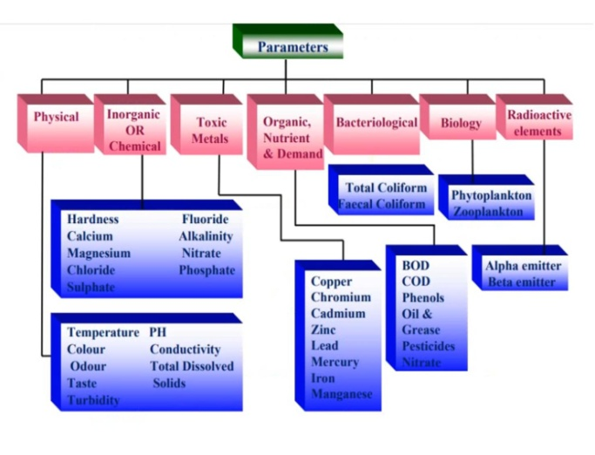

**Figure 6: Water parameter**

**1. Physical Parameters:** Physical parameter means any measurable characteristics of a Matter including temperature, pH Value, Turbidity, and TDS. Physical impurities may not have a direct relation with health but affect indirectly.

The following tests are required to carry out to know the physical characteristics of water.

1. Temperature
2. pH
3. Total Dissolved Solids (TDS)
4. Turbidity
5. Conductivity

**(a). PH Testing:**

* One of the most important water quality measurements taken is pH. This sensor uses a pH scale to test the liquids, in pH scale if any liquid having a pH value below 7 then it’s more an acidic solution and if the solution having greater than 7 then it’s a more basic solution.
* pH value varies between 0-14. Any solution having pH value 7 and its neutral solution.
* pH generally measures free hydrogen and hydroxyl ion in the water.

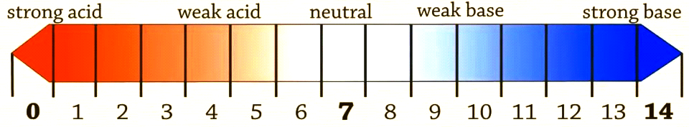

**Figure7:** pH meter

pH sensor is a device that measures hydrogen-ion based on the solution acidic and basic.

* The pH Sensor has a test-tube like structure which is made of glass, containing the sensor at the bottom
* pH sensor has a bulb to measure the concentration of hydrogen ions. To start the testing process hydrogen ions exchange their charge by other positive ions to creating a chemical potential across the sensor. The electric potential is detected by the electronic amplifier.

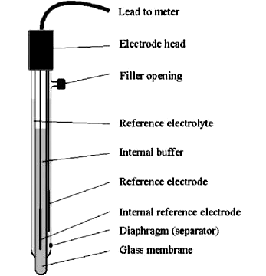

**Figure8**: Analog pH sensor

**Analog pH Meter:**

* PH sensor is basically used to measure the PH value of the solutions and define Acidity and basicity. This Sensor kit chipset supports a wide range of voltage.
* With the help of this pH sensor, It can easily construct ph meters with the help of Arduino Uno and can also view data on LCD display...
* pH Sensor has its own Arduino interface board and also has a pH probe. The Controller board has 3 pins one pin for analog sensor data read and the remaining two pins are used to provide power to the sensor

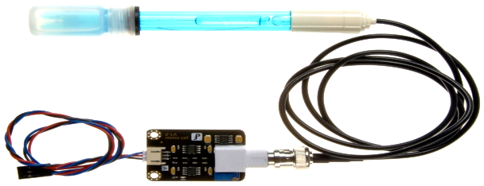

**Figure9**: Ph Sensor Kit

**Temperature Testing:**

* Temperature testing is the process of measuring the temperatures of the solution.
* Temperature also affects many parameters of water, so it’s become a very important testing phase.
* A Temperature Sensor is equipment that’s measures temperature and heat on the operating machine part. Here in this paper, using a DS18B20 to measure water temperature and temperature differences between testing also
* It uses the voltage difference to measure the temperature of the solution. The temperature sensor has three wires two for power input and 1 wire for the analog value of the sensor data.

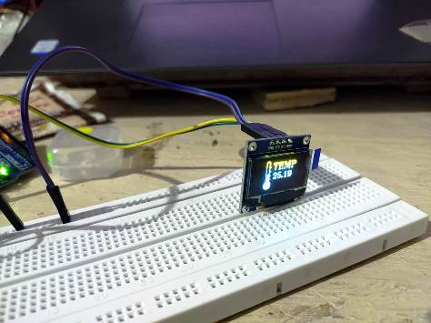

**Figure10**: Temperature sensor With Arduino and OLED display

**Turbidity Testing of Water**:

* Turbidity is a property of the water to suspend the solid present into it. A high value of turbidity gives a negative effect on the human body as well as the ecosystem. A sudden change in turbidity may be indicating new pollution sources emerging.
* The turbidity test is done with a turbidity probe and its controller board which is connected with Arduino.
* A light beam is sending by the probe to measure the value of light reflected by the water particles. When the number of particles present in the solution more light will be reflected.
* Aqua probe is capable to measure the turbidity in the range of 0-3000NTU. The turbidity sensor has 6 pins, three pins are connected to the probe, and the remaining three pins are used for analog data and power supply for the sensor.

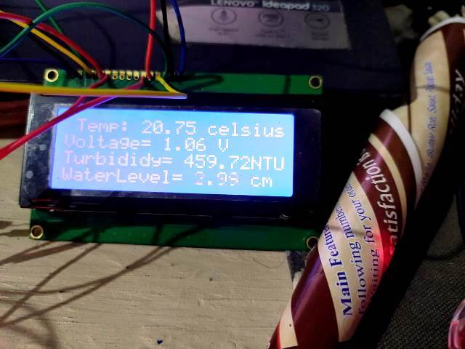

**Figure11**: Turbidity Sensor Reading on LCD

**Conductivity Sensor**:

* Conductivity is the reciprocal of an object resistivity, which is referred to the ability to carry the current in a solution; water conductivity is the value of as the ability to conduct electrons in the solution. Conductivity is also an important water quality parameter that reflects the presence of electrolytes in the given water.

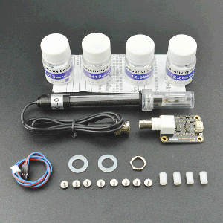

**Figure12:** Conductivity sensor

**Total Dissolved Solids (TDS) Sensor**:

* TDS refers to total substances, including inorganic salt, organic matter dissolved in a given water sample. To test the water sample the probe is dipped into the water and you can use an LCD or OLED display to take the output reading.
* TDS of water is calculated from electrical conductivity and temperature values. TDS sensor also detects all the anions and cations present in the water.
* TDS sensor also records the conductivity of water which helps to find pure water because the conductivity of pure water is almost Zero.

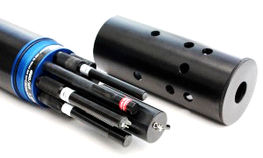

**Figure13**: TDS sensor

**2. Chemical Parameters**

1. Alkalinity test
2. Hardness of water
3. Fluoride test
4. Chloride test
5. Nitrate test
6. Calcium test
7. **Alkalinity Test:** : For testing alkaline in water, a chemical process is carried out using 2 ml of NaOH, 2 drops of phenolphthalein solution, dilute hydrochloric acid, test tube. After adding the solution, phenolphthalein gives its pink color. The alkalinity test is performed by the reaction given below:

NaOH (aq) + HCl (aq) l Nacl (aq) + H2O

1. **Hardness of water:** By EDTA METHOD

* The hardness that produces ions (ca2 + and Mg2 +) present in water, together with eriochrome black-Ti (EBT), forms an unstable complex (wine red).
* When called with EDTA (ethylene diamine tetra acetic acid), ca2 + and Mg2 + move from EBT to EDTA, forming a stable complex at Ph 9–10, leaving free EBT (steel blue).

1. **Fluoride test:**

* A fluoride test is performed to check the level of fluoride in water. Fluoride accumulates in the hard tissues of fish and shellfish and enters the food chain when organisms eat.
* Measuring fluoride in the water close to industrial areas, for example, aluminum smelting plants requires careful monitoring of fluoride levels in drinking water in water processing plants.
* High concentrations are dangerous to humans and can cause dental fluorosis, or skeletal fluorosis. In extreme cases, there are easily two main methods for measuring fluoride: the colorimetric method and the potentiometric method.
* For the direct measurement of fluoride in water samples, at this testing use the HI4010 fluoride ISE (half cell) coupled with the HI5315 reference electrode.

1. **Chloride test:**
2. Take 50 ml of sample (V ml) and dilute to 100 ml.
3. If the sample is highly colored, pour 3 ml of aluminum hydroxide and shake well, allowing the filtrate to settle, filter, wash and assemble.
4. Bring the sample to pH 7-8 by adding acid or alkali
5. Add 1ml Indicator (Potassium Chromate)
6. Titrate the solution against the standard silver nitrate solution until a reddish-brown precipitate is obtained
7. Note the volume (V1 ml)
8. Take 100 ml of distilled water in another flask and repeat steps 3 to 5 and note the amount of Ago 3 in the form of V2 ml.
9. Results determined in terms of mg / L of chloride.
10. **Nitrate test:(Nitrate rate using copper turnings test)**

* Nitrate ion is easily prominent by heating concentrated sulfuric acid as well as copper penetration.
* Then a brown, scalding flourish turns the blue litmus to red. Here sulfuric acid reacts with nitrate ions to form nitric acid.
* The nitric acid then reacts with the copper vortex to form nitric oxide. Thus nitric oxide is oxidized to nitrogen dioxide.

Cu+ 4HNO3 Cu (NO3)2 + 2NO2 +2H2O

1. **Calcium test:**

1. Take 5 ml of the sample solution in a 100 ml beaker.

2. Add 10 to 40 μL of 5M hydrochloric acid to the sample Solution and confirm that it has a pH of about 2 returns Sample Solution for Beaker.

3. Add 15 to 20 ml of Tris-hydroxy-aminomethane buffer, the solution with a pH of 6.95 is given above for the solution formed in step 2. (Thereby weakening it by a factor of 4 to 5) and confirm its pH

LAQUAtwin has changed to about 6 using pH.

A small sample of this solution is placed on the sensor

LAQUAtwin Ca2 + and measured.

**Toxic Metals**

1. **Copper test**
2. **Iron test**
3. **Chromium test**
4. **Cadmium test**
5. **Zinc test**
6. **Copper test:** Some crystals of CuSO4, burner, and boiling tube are some requirement tools for copper testing. For testing of copper in presented water, the next step involves a chemical process by taking a few crystals of copper sulfate in a dry boiling tube... After some time when the crystal is heated, the water evaporates and the crystal color gives its white color... at the end of this testing process, again wetting that crystal, the blue color of CuSO4 is tested
7. **Iron test:** Spectrophotometoric method is used to determine the concentration of iron in a water sample. Another method is using the leaf of guava plant for determining the iron in the presented water. The color will be changed from light purple to blackish color and show the presence of iron in the water.
8. **Chromium Test:**

* Chromium fragments are naturally found elements found in animals, crops, soil and volcanic dust and gases. Chromium is present in many different forms in the environment.
* No taste or odor is associated with chromium steels. The metal chromium, which is the form chromium (0), is used to make steel
* Chromium (VI) and chromium (III) are used for basil chrome plating, and dyes, reducing wood and preserving wood.
* Chromium (III) is an essential nutrient that helps the body to use sugar, protein, and fat. And is very useful for the body

1. **Cadmium Test:**

* Cadmium levels in humans begin to increase with age, which usually occurs at the age 50 and then stops.
* No cadmium is present in newborns. Interestingly, cadmium does not cross the umbilical-fetal barrier nor lead and mercury to the blood-brain barrier
* So it is not toxic to the fetus, nor does it account for the mental and brain effects of lead and mercury.

1. **Zinc Test:** Inadequate zinc can cause loss of appetite, lack of taste and smell, slow wound wounds, and skin wounds. Zinc deficiency can also cause birth defects.

**Other Metal Test**

* Arsenic Test

**Arsenic test:**

* Take 15 ml of the water sample is taken in a test tube and very small amounts of potassium iodide (KI) and stannous bromide (SnBr2) are added which will act as a reducing agent.
* A small amount of zinc (Zn) and hydrochloric acid (HCI) is then added, which reacts with As3 + present in the water sample and produces arsine gas.
* Color changes (red-brown diabetes) resulting from the reaction of arsine gas with modified mercury (II) bromide discs, the presence of arsenic in the water sample (no color = absence or below the level of detection) Indicates.
* So, water samples can be easily detected by observing the color scale (Annex-1) and with the help of the chemistry of arsenic measurements by the mercuric bromide stain method (Annex-2).

**The Microbiological parameter in water:**

Examination of Microbiological in drinking water, a presumptive test is done using Macconkeybroath or lactose broth in a single and double strength concentration. A common standard chart is represented by the record of the total number of bacteria present. Other microorganisms in addition to coliform bacteria also produce as well as gas from lactose fermentation

.

1. Total Coli form
2. E-coli

**Chemical testing With Arduino Uno**

1. During the chemical test, servo motor will be connected to Arduino Uno and then mini water pump motor will also connected to Arduino for processing test.
2. After conducting the chemical test, whatever reaction was obtained after the test, some colors were found in which IoT based color sensor was used to identify it.
3. After the chemical test, some color came in the reaction, for which color sensors were used.
4. TCS 230/TCS 3200 color sensor with Arduino Uno mostly used in chemical testing for detecting the color.

Color sensor name: TCS 230/ TCS 3200, TCS 34725 C9303-04, TCS 3725.

**6. EXPERIMENTAL SETUP**

1. In the experimental setup, first the 5 volt output pin of the Arduino will be used to deliver power to the sensor. And the analog pin of Arduino will be used to take data from the sensor. After giving power to all sensors, analog pins will be defined in the code. This process will be done with all types of sensors.
2. After taking 2 to 3 types of water samples, the sensor will be immersed and the code will be compiled and uploaded by connecting the Arduino to the laptop.
3. 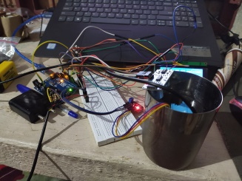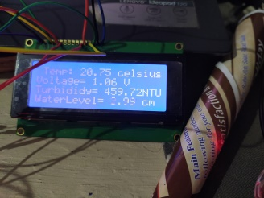Subsequently, the result will be displayed on the LCD screen, OLED screen and webpage. The arduino will have to be connected to the internet to see the results on the webpage This data can be stored for processing purpose.

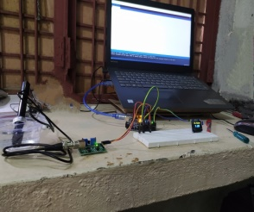

**Figure 14:** Experimental setup

**Software:**

In this paper, Arduino Integrated Development Environment (IDE) supports coding. The source code has run in C and C ++, and Python programming languages. It is easy to program, and testing is implemented with each sensor for different and then integrated into the entire system. Review sensors are interfaced with the Arduino board and connected the Arduino via USB cable to the sub-port, that Arduino board type is selected and IDE and compiled the code, and uploaded the code. The outputs have shown in the serial monitor of the IDE. The given standard output has been displayed with the sensors in an OLED display or silicon display.

**7. RESULT AND ANALYSIS :**

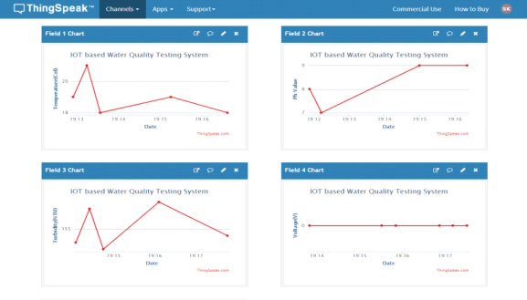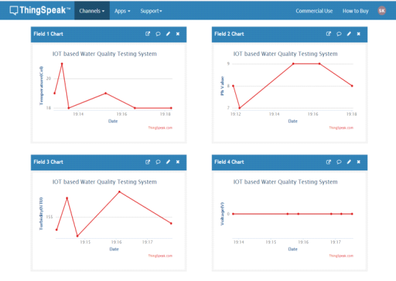 According to all sensors, the water will be tested to see if it is potable and the number and quality of impurities found in that water will also be known. And the processing of all water sample data can be viewed on any mobile and laptop with the help of a web page, as well as the result can be seen on OLED display and 20X4 LCD screen as well. With the help of this setup, many water samples are tested and one can easily find out the difference between safe and unsafe water for peoples, it takes less than 2 minutes to test any water sample. Some results have been showing in the snapshot that has been taken with different water samples. Graphical representation of some water samples has been drawn as below.

** Figure 15**: Parameters Graph between different Water Samples

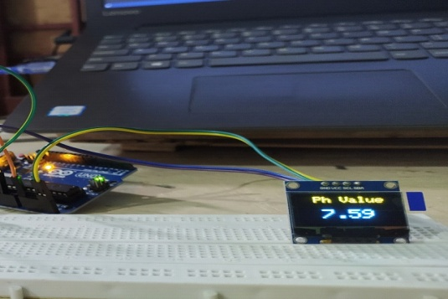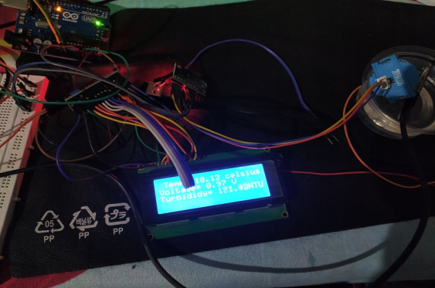

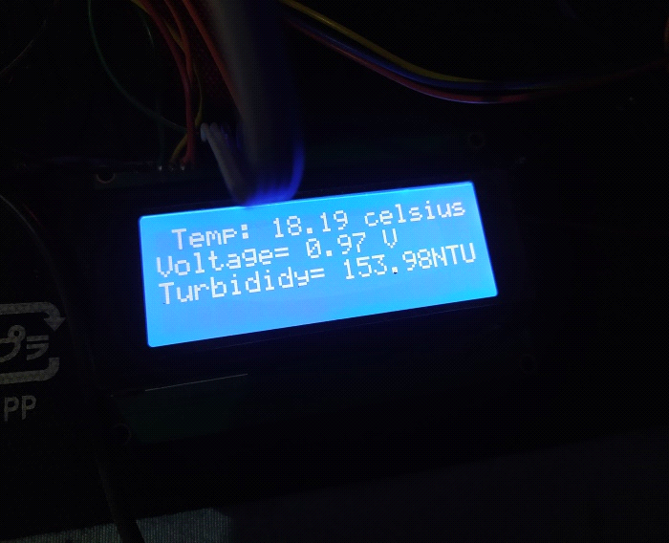**Figure16**: Results on the LCD display

**8. CONCLUSION:**

At the end of this paper, a portable device is designed in which all parameters of water quality can directly be detected through the sensors and It will be successfully used water parameters such as temperature, pH, conductivity, TDS, and many chemicals. Have done did research. And furthermore, the determination of relative value for the water level and measure the water consumption through the sensor.

**Future Work scope:**

* This paper will save time. Earlier, different sensors are needed to generate water parameters, TDS, but now through the paper, all the parameters can be received whether they are physical or chemical simultaneously.
* In the future, more water quality parameters can also be found with the use of sensor calibration and ML.
* In the future, the concept of new technologies of IoT, AI, and ML can be mentioned in this paper.
* Through this paper, it will be easy to find the reading work of parameters related to water (PH, TDS, and Conductivity, etc).

**REFERENCES**

[1] Chowdury, M., Emran, T., Ghosh, S., Pathak, A., Alam, M., Absar, N., Andersson, K. and Hossain, M., 2019. IoT Based Real-time River Water Quality Monitoring System. *Procedia Computer Science*, 155, pp.161-168.

[2] Daigavane, V. and Gaikwad, M., 2017. Water quality monitoring system based on IoT*. Department Electronics & Telecommunication Engineering, Advances in Wireless and Mobile Communications*, 10(5), pp.1107-1116.

[3] Ramesh, M.V., Nibi, K.V., Kurup, A., Mohan, R., Aiswarya, A., Arsha, A. and Sarang, P.R., 2017, October. Water quality monitoring and waste management using IoT. In 2017 IEEE Global Humanitarian Technology Conference (GHTC) (pp. 1-7).IEEE.

[4] Mohammadi, Sevda, Anupama Vijaya Nadaraja, Deborah J. Roberts, and Mohammad H. Zarifi. 2020. "Real-Time And Hazard-Free Water Quality Monitoring Based On Microwave Planar Resonator Sensor". *Sensors and Actuators A: Physical* 303: 111663. doi:10.1016/j.sna.2019.111663.

[5] Chen, Yiheng, and Dawei Han. 2018. "Water Quality Monitoring In Smart City: A Pilot Project". *Automation in Construction* 89: 307-316. doi:10.1016/j.autcon.2018.02.008.

[6] Koditala, N. and Pandey, P., 2018. Water quality monitoring system using IoT and machine learning. *International Conference on Research in Intelligent and Computing in Engineering (RICE),* (pp. 1-5).IEEE

[7] Niswar, M., Wainalang, S., Ilham, A.A., Zainuddin, Z., Fujaya, Y., Muslimin, Z., Paundu, A.W., Kashihara, S. and fall, D., 2018, November. IoT-based water quality monitoring system for soft-shell crab farming. In 2018 IEEE International Conference on Internet of Things and Intelligence System (IOTAIS) (pp. 6-9). IEEE.

[8] Jiang, Jiping, Sijie Tang, Dawei Han, Guangtao Fu, Dimitri Solomatine, and Yi Zheng. 2020. "A Comprehensive Review on the Design and Optimization of Surface Water Quality Monitoring Networks". *Environmental Modeling & Software* 132: 104792. doi:10.1016/j.envsoft.2020.104792.

[9] Kumar, M.V., and K. Samalla. 2019. "Design and Development of Water Quality Monitoring System In Iot". *International Journal Of Recent Technology And Engineering (IJRTE)* 7 (5S3), 412-418.

[10] S. Kartakis, W. Yu, R. Akhavan, and J. A. McCann, "Adaptive Edge Analytics for Distributed Networked Control of Water Systems," 2016 IEEE First International Conference on Internet-of-Things Design and Implementation (IoTDI), Berlin, 2016, pp. 72-82, DOI: 10.1109/IoTDI.2015.34.

[11] Madhavireddy, Vennam, and B. Koteswarrao. 2018. "Smart Water Quality Monitoring System Using Iot Technology". *International Journal of Engineering & Technology* 7 (4.36):636.doi:10.14419/ijet.v7i4.36.24214.

***Diagram’s wise References***

1. <https://www.pollinator.org/pollinator.org/assets/generalFiles/Pollinator-Partnership-2019-Final-Report.pdf>

3.1. [Analog pH sensor kit for arduino]. Retrieved from <https://www.electronicscomp.com/analog-ph-sensor-kit-for-arduino>

3.2 “Water Proof Temperature Probe.” *Robu.in*, robu.in/product/ds18b20-water-proof-temperature-probe-black-1m-2/.

3.3 Best *TDS Meter for Drinking Water*. images.app.goo.gl/rzg34jPhHXA8sjkGA.

3.4 “Turbidity Sensor.” *IoT Web Planet*, www.iotwebplanet.com/product/turbidity-sensor/.

3.5 <https://web-material3.yokogawa.com/product_SC42_Smallbore_GS_02.us.pdf>

3.6 “Dissolved Oxygen Sensor.” *Thingbits*, ms-my.facebook.com/marketplace/item/2044841492273563/?ref=mini_shop_storefront&referral_code=mini_shop_marketplace_pdp_shop_info.

3.7 “Arduino UNO.” *Robu.in uploads the*, robu.in/product/arduino-uno-r3-without-cable/.

3.8 *Https://Www.google.com/Url?Sa=i&Url=Http%3A%2F%2Fwww.Dudigan.com%2F2018%2F02%2Fbloklarla-Arduino-Mblock-Ile-Reed-Role-Kullanarak-Hirsiz-Alarm%2F&Psig=AOvVaw2hkZdz5NvseAZnMPIZ4Mjb&Ust=1611908804452000&Source=Images&Cd=Vfe&Ved=2ahUKEwiZge-umr7uAhVygEsFHQRyAmYQr4kDegQIARAg*, Hardware Programmer, i.stack.imgur.com/klnNx.jpg.

3.9 “OLED Display Arduino.” *Electronic Wings*, lastminuteengineers.com/oled-display-arduino-tutorial/.

3.10 *Wi-Fi Module for Arduino*. osch.oss-cn-shanghai.aliyuncs.com/blogPicture/1548299411345.jpg.

3.11 *Buzzer*. https://albavibel.neocities.org/arduino/speakerpiezo.jpg.

9. *Analog PH Sensor*. images-na.ssl-images-amazon.com/images/I/41bdvZ07N1L._UL500_.jpg.

12. *Analog Electric Conductivity Sensor*. Dfrobot, https://www.dfrobot.com/product-1123.html?search=dfr0300&description=true.

13. *TDS Sensor*. Aquared, www.envieq.com/wp-content/uploads/2017/01/AP-7000-250x250.jpg.

14. *WHO Report Details*. . https://www.who.int/news-room/fact-sheets/detail/drinking-water#:~:text=785%20million%20people%20lack%20even,dysentery%2C%20typhoid%2C%20and%20polio.